Postman NeuroTech Task 2

Project Name: NeuroSync (tentatively)

Basic Outline:

This project is designed to enhance cognitive function through a closed-loop brain-computer interface (BCI) system. It integrates real-time EEG signal processing, **machine learning algorithms**, personalized cognitive enhancement protocols, and a user-friendly interface (final step of the project). It’ll offer a tailored approach to improve cognitive function. Through continuous monitoring of brain activity and dynamically adjusting interventions based on individual responses, NeuroSync will maximize effectiveness.

Existing Projects and Research:

Existing projects and research in the field of neurotechnology have explored various approaches to cognitive enhancement, including brain-computer interfaces (BCIs), neurofeedback, and transcranial stimulation. These initiatives typically focus on generic interventions that target broad cognitive domains or employ one-size-fits-all protocols. NeuroSync stands out by offering a personalized approach to cognitive enhancement that is tailored to the individual's unique neurophysiological profile and cognitive needs. By integrating real-time EEG signal processing with machine learning algorithms, NeuroSync decodes cognitive states with precision and adapts interventions in real-time to optimize effectiveness. This personalized approach allows NeuroSync to deliver targeted cognitive enhancements, maximizing outcomes while minimizing side effects.

Implementation of machine learning is what will make the model different and through rigorous training of the model, we can make it more effective. In a college as huge as ours we can have many people test the model as it’ll be quite safe and if it reaches to that stage, can be brought further ahead to apply at various places. With the help of superiors and professors, we can verify the model results with some experts and compare the results’ accuracy. The model can be further tweaked as required.

Major Challenges:

Individual Variability: One major challenge is the inherent variability in neurophysiological responses among individuals, necessitating personalized approaches for effective cognitive enhancement. This will be very time consuming as in the initial stage, each of the results need to be tailored. We can start with the data available online to train before we bring in individuals to try. Just until we start basic training as after that, we would want it to be a realtime project, syncing everything like the name suggests. Implementing **adaptive algorithms** that continuously learn and adapt to individual neurophysiological responses will be crucial for addressing variability and optimizing cognitive enhancement outcomes.

Real-time Processing: Processing brain signals in real-time and delivering adaptive interventions pose technical challenges in terms of signal processing speed, accuracy, and latency. We will need the required resources( I don’t know what all is available with the lab and what all can be arranged).

Ethical Considerations: Ethical concerns related to privacy, consent, and potential misuse of neurotechnology for cognitive enhancement need to be addressed. This is something we’ll need to consider thoroughly when we bring this out and implement it in real life.

Flow Of The Project:

* EEG Signal Acquisition:

EEG signals are captured using high-density EEG sensors placed on the scalp.

The OpenBCI Python library provides a convenient interface for interacting with OpenBCI EEG hardware, streaming EEG data, and performing real-time signal processing.

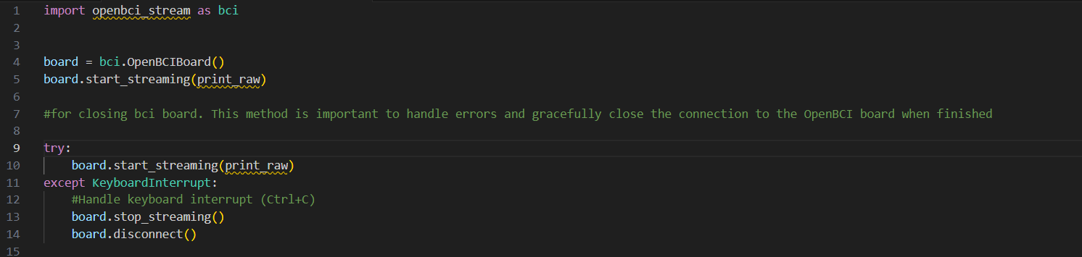

* Real Time Signal Processing

Raw EEG data is preprocessed using filters (e.g., notch, bandpass) to remove artifacts and extract relevant frequency bands. This is quite similar to what I had done in task1.

Feature extraction techniques (e.g., power spectral density, entropy measures) are applied to extract features indicative of cognitive states.

Advanced signal processing techniques such as wavelet transforms or adaptive filtering may be employed for artifact removal and feature extraction.

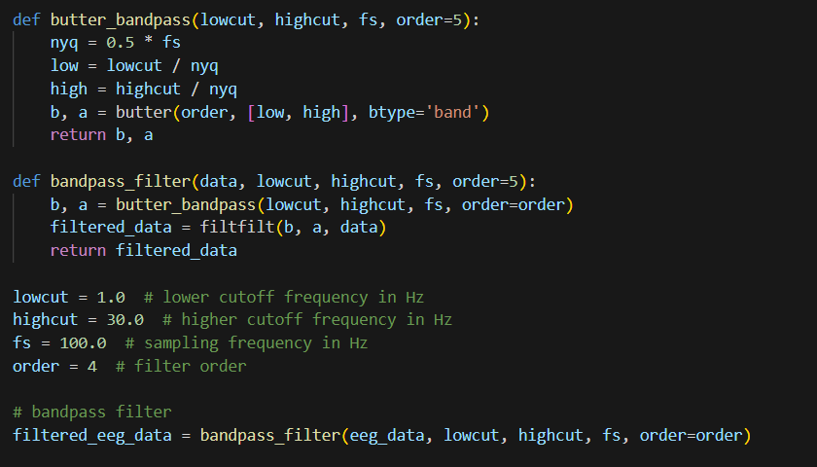

* Machine Learning for Cognitive State Decoding: (V.Imp)

Supervised learning algorithms (e.g., support vector machines, neural networks) are trained on labeled EEG data to decode cognitive states such as attention, memory, and workload.

Transfer learning techniques may be employed to adapt pre-trained models to individual users.

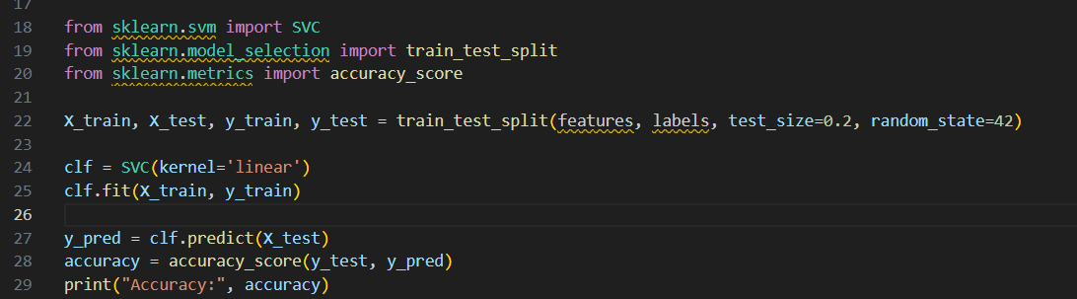

This code snippet demonstrates the training and evaluation of a Support Vector Machine (SVM) classifier using the scikit-learn library within the context of the NeuroSync model. First, the dataset is split into training and testing sets using the `train_test_split` function, with 80% of the data used for training (`X_train`, `y_train`) and 20% for testing (`X_test`, `y_test`). This step is crucial for evaluating the model's performance on unseen data, ensuring that it generalizes well. The SVM classifier (`clf`) is then initialized with a linear kernel and trained on the training data. The trained classifier is then used to predict the labels for the testing data (`X_test`), and the accuracy of the predictions is evaluated by comparing them to the true labels (`y_test`). Finally, the accuracy score is calculated and printed. This process is essential for assessing the effectiveness of the machine learning model in classifying cognitive states based on EEG features, thus informing the adaptive interventions in the NeuroSync system.

* Personalized Cognitive Enhancement Protocols: (This is what makes the project diff)

Based on decoded cognitive states, personalized cognitive enhancement protocols are dynamically generated.

Neurofeedback training tasks and transcranial electrical stimulation parameters are adjusted in real-time to optimize cognitive performance.

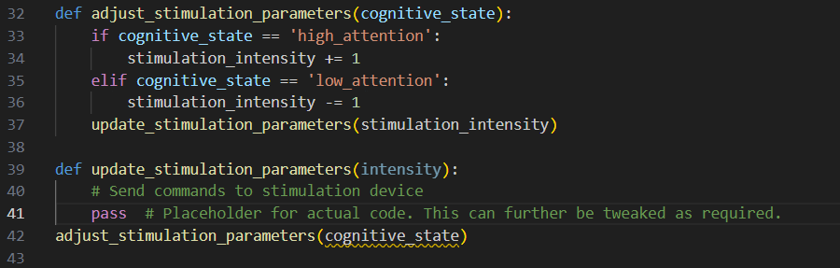

This code snippet defines a function `adjust_stimulation_parameters` that takes the current cognitive state as input and adjusts stimulation parameters accordingly within the context of the NeuroSync model. Based on the received cognitive state, which could indicate levels of attention, the function modifies the `stimulation_intensity` variable, increasing it if the cognitive state indicates high attention and decreasing it if the state suggests low attention. Following the adjustment, the function calls `update_stimulation_parameters` to update the stimulation parameters in the stimulation device. This code is crucial within the NeuroSync system as it enables dynamic adaptation of cognitive enhancement interventions based on real-time cognitive states decoded from EEG signals. By adjusting stimulation parameters in response to changes in cognitive states, NeuroSync can optimize the effectiveness of interventions and enhance cognitive performance tailored to individual needs.

* Display Of Results and User Interface

A user-friendly interface allows users to monitor their cognitive states, customize settings, and provide feedback.

Graphical visualizations display real-time EEG data, decoded cognitive states, and stimulation parameters.

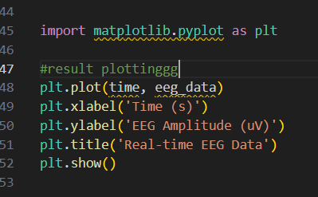

Conclusion:

In conclusion, NeuroSync represents a pioneering project in the field of neurotechnology, offering a personalized and adaptive solution for cognitive enhancement. To successfully implement NeuroSync, significant resources are required, including EEG hardware, computational infrastructure for real-time signal processing and machine learning, and expertise in neurophysiology and machine learning. Additionally, partnerships with research institutions, healthcare providers, and technology companies can provide valuable resources and expertise. To further improve the plan, continuous refinement and validation of machine learning models, optimization of stimulation protocols, and rigorous testing in real-world settings are essential. Furthermore, incorporating feedback from users throughout the development process can enhance usability, effectiveness, and ethical considerations. With careful planning, collaboration, and innovation, NeuroSync has the potential to revolutionize cognitive enhancemen